Song: We are the Champions

Length of time to complete activity: 30 minutes Level: 4

Target Grammar Point: Present Perfect
Corresponding Unit:

# of students needed for activity: Individual activity

Learning Objectives:
- Students will be able to identify grammatical errors in a song.
- Students will be able to correct grammatical errors in a song.
- Students will be able to discuss meaning of a song.
- Students will be able to expand vocabulary through song.

Materials Needed:
- Song: We are the Champions by Queen via YouTube - https://www.youtube.com/watch?v=C2NU98NZF8o
- Song Worksheet (make double sided copies of pages 2 and 3)
- Answer key (pages 4 and 5)
- Pencil/Pen

Instructions:
- Ask students if they’ve know who Queen is. Elicit student responses.
  - Queen is a British rock band formed in 1970. They have many famous songs including Bohemian Rhapsody and We Will Rock You and We are the Champions, which are often played at sports games. They have 18 number one albums and 18 number one singles. They are one of the world’s best-selling music artists and are in the Rock and Roll Hall of Fame.
- Ask students if they’ve ever heard of the song before. Elicit student responses.
- Ask students to guess what they think the song will be about.
- Pass out song worksheet to students.
- Tell students to try to find the 10 grammar errors in the song and correct them.
- Play song for students twice. Tell students that they can check their answers as they listen to the song.
- Discuss the grammar errors and discuss meaning of song with students. Here are some possible discussion questions:
  - Why does Queen use present perfect?
  - How does this song make you feel?
  - What is this song about?
- Go over any unfamiliar words with students.

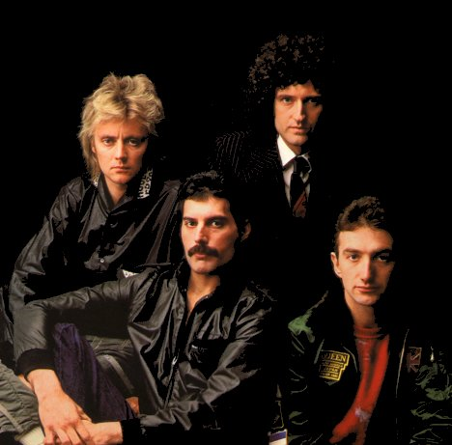
We are the Champions by Queen

Directions: In the following song, there are 10 present perfect errors. Underline the errors and correct them. Then you will listen to the song twice. Check your answers as you listen to the song.

I has pay my dues
Time after time
I've did my sentence
But committed no crime

And bad mistakes
I has make a few
I've has my share of sand
Kicked in my face
But I've came through
And we mean to go on and on and on and on

We are the champions - my friends
And we'll keep on fighting
Till the end
We are the champions
We are the champions
No time for losers
'Cause we are the champions of the world

I've took my bows
And my curtain calls
You brought me fame and fortune
And everything that goes with it
I thank you all

But it have be no bed of roses
No pleasure cruise
I consider it a challenge before
The whole human race
And I ain't gonna lose
And we mean to go on and on and on and on

We are the champions - my friends
And we'll keep on fighting
Till the end
We are the champions
We are the champions
No time for losers
'Cause we are the champions of the world

We are the champions - my friends
And we'll keep on fighting
Till the end
We are the champions
We are the champions
No time for losers
'Cause we are the champions

Answer Key

I've paid my dues
Time after time
I've done my sentence
But committed no crime

And bad mistakes
I've made a few
I've had my share of sand
Kicked in my face
But I've come through
And we mean to go on and on and on and on

We are the champions - my friends
And we'll keep on fighting
Till the end
We are the champions
We are the champions
No time for losers
'Cause we are the champions of the world

I've taken my bows
And my curtain calls
You brought me fame and fortune
And everything that goes with it
I thank you all

But it's been no bed of roses
No pleasure cruise
I consider it a challenge before
The whole human race
And I ain't gonna lose
And we mean to go on and on and on and on

We are the champions - my friends
And we'll keep on fighting
Till the end
We are the champions
We are the champions
No time for losers
'Cause we are the champions of the world

We are the champions - my friends
And we'll keep on fighting
Till the end
We are the champions
We are the champions
No time for losers
'Cause we are the champions

